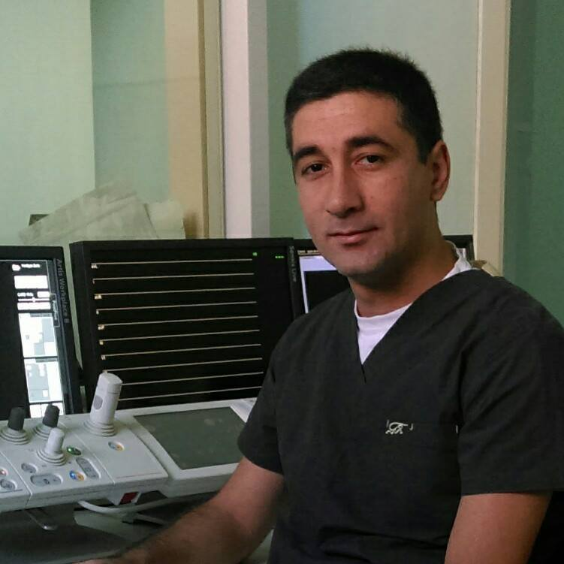
Arsen Tsaturyan, MD
Interventional cardiologist
Erebouni MedicalCenter,

Work address:
14 Titogradyan Str, Yerevan, Armenia, 0087
Phone: +374 10 47 23 40

Mailing address:
2 Lvovyan street, apt 35, Yerevan, Armenia, 0056
Cell: +37493246909
Email: dr.tsaturyan@gmail.com

Work Experience

2012-present Interventional cardiologist
Erebouni Medical Center

2009-2012 Ambulance Physician
Erebouni Medical Center

2007-2009 Ambulance nurse
Erebouni Medical Center

Procedures first performed in Armenia

2013 Embolization of uterine fibroids
2014 Transcatheter arterial chemoembolization of liver tumors
2016 Embolization of prostatic artery

Education and Trainings

2009-2012 Clinical residency in cardiology and interventional cardiology
Yerevan State Medical University after M. Heratsi

12.2012 Hands-on training in interventional vascular radiology of heart and peripheral vessels
Institute of Cardiovascular Surgery named after Bakulev
Moscow, Russia

2003-2009 MD degree
Yerevan State Medical University after M. Heratsi

11.2017 Hands-on Microcatheter Embolization Workshop
Magdeburg, Germany

11.2016 EAPCI Learning Program on ESCeL Platform
Completed successfully

12.2015 Carotid Artery Stenting Workshop
Motol University Hospital
Prague, Czech Republic

06.2016 Prostatic artery Embolization for BPH Workshop
St Luis Hospital
Lisbon, Portugal

11.2017 Microcatheter embolisations workshop
Magdeburg, Germany

09.2021 TAVI workshop
Nur Sultan Kazakhstan

Membership

Armenian Interventional Cardiology and Radiology Association
European Society of Cardiology
European Association of Percutaneous Cardiovascular Interventions
Armenian Association of Interventional Cardiology and Vascular Radiology
Cardiovascular and Interventional Radiological Society of Europe(CIRSE)
Languages Spoken
Armenian: Native,
English: Upper intermediate
Russian: Advanced

Main interested area – Interventional cargiology, Vascular interventional radiology

